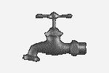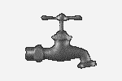Sutherland Creek Waterworks District

S.C.W.D.

Box 466, Christina Lake, B.C. V0H 1E0

Phone/Fax 250-447-6188

Email: [scwd1974@gmail.com](mailto:scwd1974@gmail.com)

*May 2, 2022*

*This is further to our letter dated April 1, 2022 advising that our new 270,000-gallon storage tank will be commissioned late May or early June.*

*We are pleased to advise that our project will be completed on schedule*

*and within budget.  At this time, we need to prepare for transition from our*

*current reservoir to the new tank.*

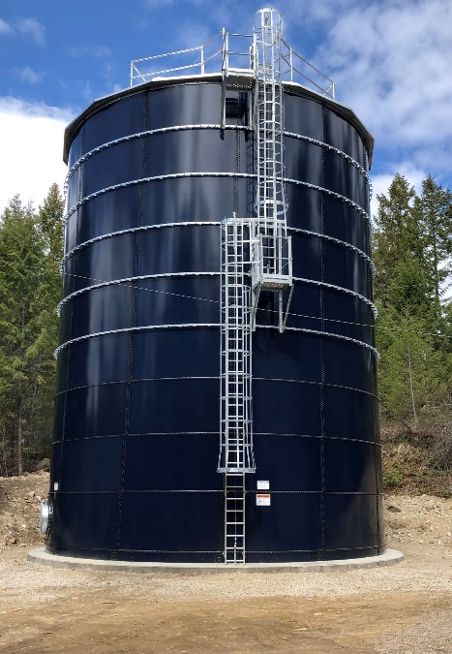*Transitioning will result in a disruption of service that could extend up to eight hours.  It will be planned on a day and time of day to cause minimal impact on service.  You will be given notice by telephone and/or email a day or two in advance of the exact time period.  We will ask that you do not use any water during the transition period to avoid depleting our water main’s.*

*Our new storage tank will result in a 10-15 psi increase of line pressure which will be of value for most property owners.  However, at lower elevations on our system line pressure may exceed 80 psi.  As such we encourage the use of pressure reducing valves to protect against damage that can result from additional water pressure.*

*If you haven’t seen our new storage tank, take a ride up Fife Road.  It’s an impressive structure that will provide an ample amount of quality water and improved fire protection for many years to come.*

*Board of Trustees*